**Istio Installation**

Istio Setup:

Method selection <https://istio.io/latest/about/faq/#install-method-selection>

* Download & install istio:

<https://istio.io/latest/docs/setup/getting-started/#download>

* Windows instance:

Ensure kubectl is installed and then install istioctl 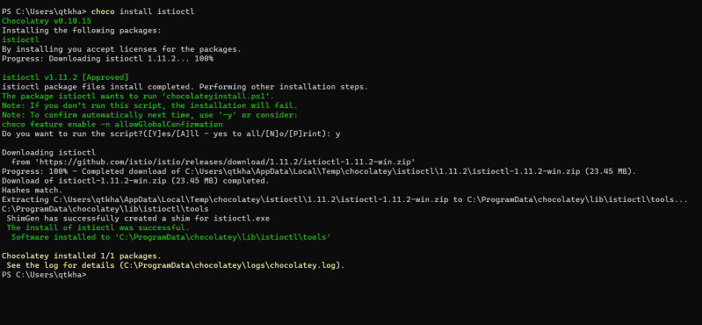

Linux Instance (Azure)

Install azure cli <https://learn.microsoft.com/en-us/cli/azure/install-azure-cli-linux?pivots=apt>

sudo apt update

curl -sL https://aka.ms/InstallAzureCLIDeb | sudo bash

az login

Now lets create a aks cluster <https://learn.microsoft.com/en-us/azure/aks/learn/quick-kubernetes-deploy-cli>

Now download istio by following steps https://istio.io/latest/docs/setup/getting-started/#download

Now let’s create istio <https://istio.io/latest/docs/setup/getting-started/#install>